**Year 9 Book Review**

This book is a bit like:

‘She who became the Sun’

‘Cage of Souls’

‘Legacy of Ash’

A little bit about the book:

This book has a variety of poetic elements and introduces our female lead –Alizeh- who is a maid and has faced many obstacles in her life, yet has never failed to defend herself and remain fierce in her heart. There is a monarchy/Kingdom and we are also given the point of view of Kamran, who is a Prince. There are many plot twists and strong emotions, which they both have to face in order to restore justice and live up to their morals. It is a series, so consider yourselves hooked.

I am reviewing....

This Woven Kingdom

Written by...

Tahereh Mafi

Review by Mishel

This book is:

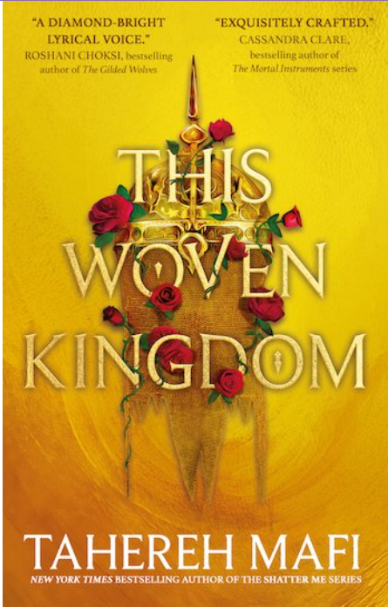

I liked this book because:

Alizeh has a secret, which she may never share as an heir to the Jinn crown, forced to seek shelter as a servant girl to evade those who would have her killed.

The book itself has strong vocabulary with metaphors and tension/conflict through the individuality as well as differences within the characters. A highly enjoyable book to read if you are someone who craves mystery, tension/drama, royalty and a desire for refuge.

I would rate this book:

Non-fiction

Fiction