**Year 9 Book Review**

This book is a bit like:

Neverworld Wake

A little bit about the book:

Ariel's accidental meeting with a handsome stranger called Joe is completely perfect; they have a connection like she's never known before. They exchange numbers and agree to meet when he is back from a trip to France. But when Ariel messages him, the number Joe gave her is disconnected. He's ghosted her. She assumes she will never see him again.

I am reviewing....

Ghosted

Written by...

Emily Barr

Review by Ammarah

This book is:

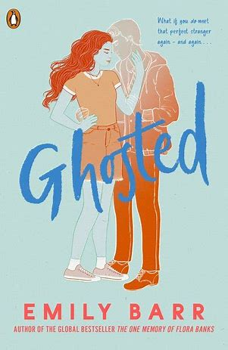

I liked this book because:

It turned out very different than I had expected it to. It was more of a murder mystery book than anything else. Death is a recurring motif in the novel and the book has a thrilling element to it. If you want a book that will keep you by surprise, read this.

I would rate this book:

Non-fiction

Fiction