**Year 8 Book Review**

**Why I like this book:**

because Ben has no idea that he has a sister and there is a murderous madman that keeps following him, but for a certain reason. This book keeps you hooked until the very end. It is set in India and there is a mystery house that holds a lot of secrets.

I am reviewing....

The Midnight Palace

Written by...

Carol Ruiz Zafon

Review by...

Amina

This book is:

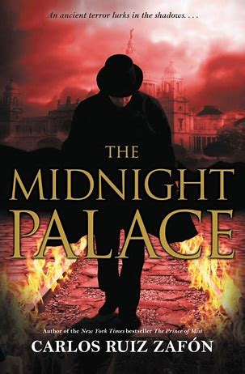

I would rate this book:

Non-fiction

Fiction

A little bit about the book:

The Midnight Palace begins on a dark night when an English lieutenant fights to save newborn twins Ben and Sheere from an unthinkable threat. Despite monsoon-force rains and terrible danger lurking around every street corner, the young lieutenant manages to get them to safety, but not without losing his own life. . .

**What this book is like:**

**The Prince of Mist**