**Year 8 Book Review**

**Why I like this book:**

The book was full of adventure and mystery, making me feel like I was in an adventure myself. The characters are spooky and eerie, but in particular, I really enjoyed the book, because it is about friendship, as the two characters in the novel show each other support throughout their whole journey.

I am reviewing....

The house on hoarder hill

Written by...

Mikki Lish and Kelly Ngai

Review by...

Ayesha

This book is:

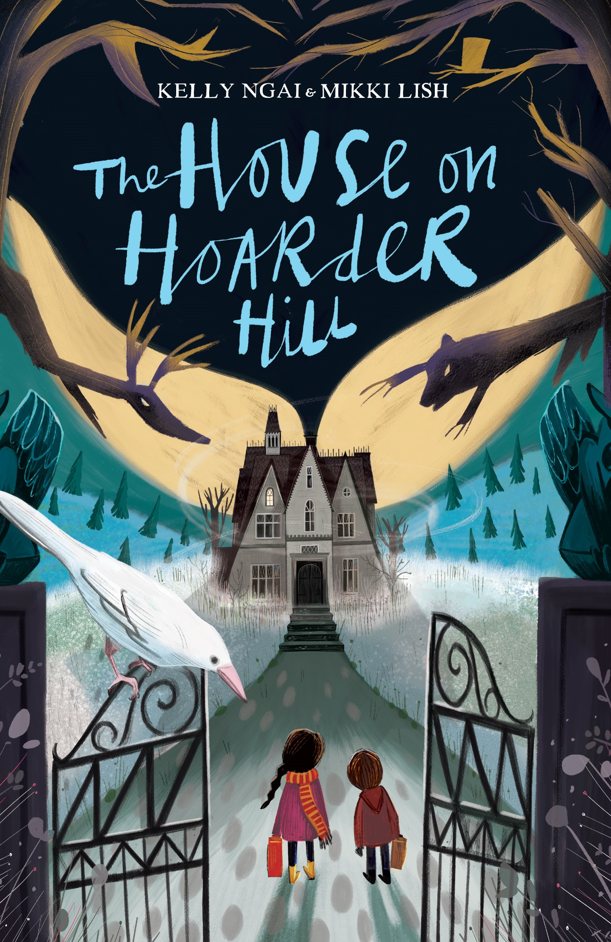

I would rate this book:

Non-fiction

Fiction

A little bit about the book:

Hedy and Spencer, the main characters, see cryptic messages in their grandfather’s spooky house on Hoarder Hill and their holiday has a sinister turn. With the help of a (talking) stag’s head, a bear rug and other peculiar spirits, the children set out to discover the disappearance of their grandmother.

**What this book is like: It is also like The Last Chance Hotel**

