Book review: One of us is Lying
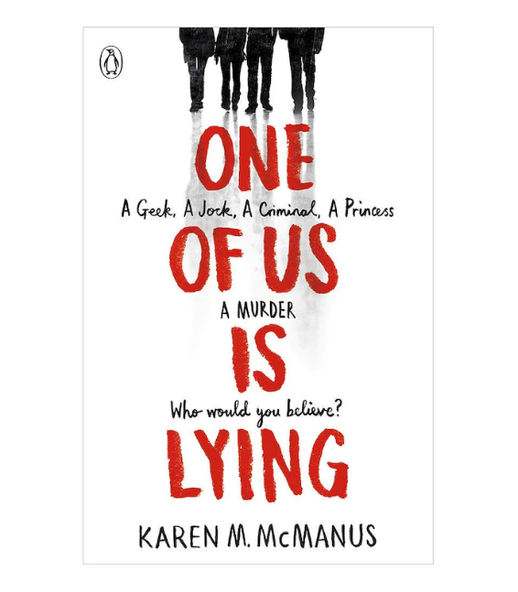
At first, I simply read this book because it was trending and had no actual interest in it. I presumed it’d be your usual mystery book, something easy to move on from with no twists. At first, that’s what it seemed like too. But as I kept reading, the events kept leaving me questioning all of mine and the character’s suspicions. And then the plot was unveiled, and I was left in awe, questioning everything. It was one of the most epic plots I’ve experienced, and for those wanting a book to keep them guessing, I would recommend this.

Book review: The Cruel Prince
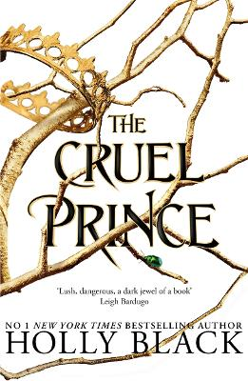
From the first word of this book till the last, I was completely in love. The story line, description, romance, politics and story line make this not just a book, but one of the finest pieces of art. It’s a blend of all themes I adore, and not a single sentence left me bored. I remember being unable to drop the book but dreading the end, because the emotions felt through this book is something words cannot explain. The selective range of vocabulary Black has used down to the structure perfectly presents each character’s emotion and motive, regardless of the complexity. Since this book is of the young adult genre, I would recommend this for readers above the age of 13. Overall, I and everyone who has read this is almost intoxicated by love for it.
Book review: Harry Potter and the Deathly Hallows
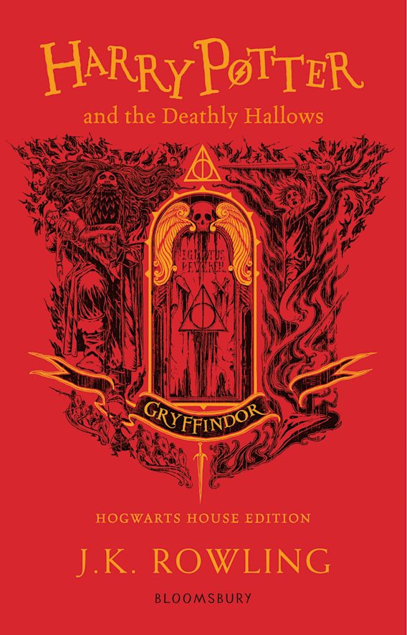
I always say my favourite of the Harry Potter series is Philosopher stone, however I only say that to avoid talking about the trauma this book has inflicted on me. I am notorious for never crying, no matter what happens. This book, however, is the first story (not even book) I have cried because of. I remember having to take so many breaks from reading because at points I could not bear the pain. The way Rowling displays the pains of Harry, Hermione and Ronald left me feeling a hole in my heart. Not to mention how Rowling finally showcased Professor Snape’s real emotion, motive and love for the Potters, despite the pain James Potter inflicted. Even the Patronus symbolised such a beautiful thing, and to call it simply love would do it injustice, because it was much more endearing and promising than love. The one quote that forever lives in my heart represents a small percentage of this love. The quote is, ‘’After all this time?’ ‘Always.’’And even after all of that, Rowling ‘kills’ Harry, the character I was always emotionally connected to due to our many unseen similarities, and the way Rowling has the audacity to present it in an underwhelmingly short sentence left me in a bigger shock. At that point, I had finally dropped the book, and went looking for someone to share my pain with. It was as if I witnessed his death, and I could never imagine the pain Hagrid felt. I would recommend this well-written book to those who adore themes of conflict, pain, justice and enjoy being messed with, since this was the only book to ever make me cry. This book left me feeling proud of being a Potterhead and a Gryffindor. (But ensure you read all 6 books before this one to truly comprehend the significance of each word.)

