**Year 7 Book Review**

A little bit about the book:

Stephanie's uncle Gordon is a writer of horror fiction. But when he dies and leaves her his estate, Stephanie learns that while he may have written horror, it certainly wasn't fiction. Pursued by evil forces intent on recovering a mysterious key, Stephanie finds help from an unusual source the wisecracking skeleton of a dead wizard. When all hell breaks loose, it's lucky for Skulduggery that he's already dead. Though he's about to discover that being a skeleton doesn't stop you from being tortured, if the torturer is determined enough.

**I liked the book because:**

I think the storyline and plot was incredibly mysterious and cunning reflecting the book perfectly. The writing style and use of language helped you to easily get lost in the story. Furthermore, this book had the ability to capture your attention as if you were there in the moment.

I am reviewing....

Skulduggery pleasant

Written by...

Derek Landy

Review by

Zainab

This book is:

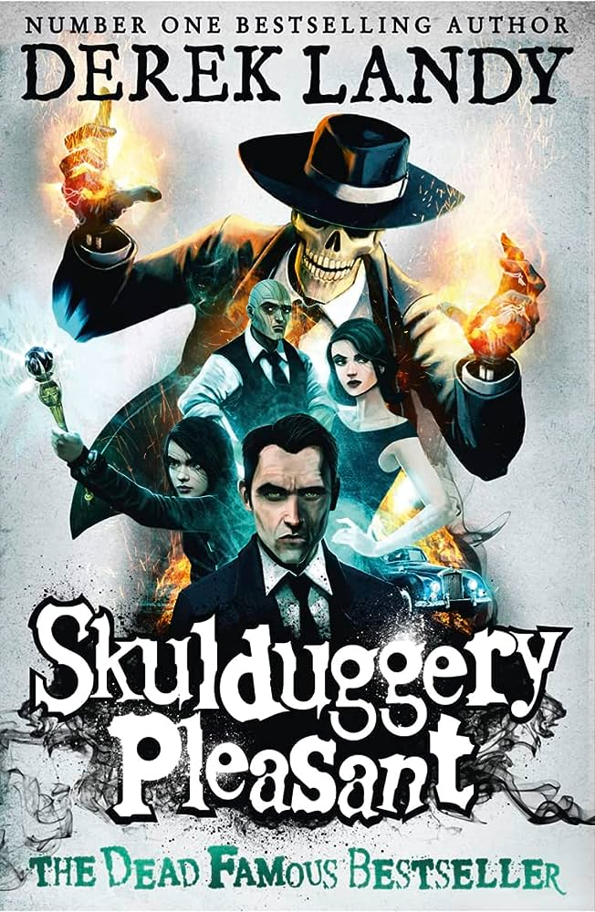

**This book is a bit like:**

**Spiderwick Chronicles**

I would rate this book:

Non-fiction

Fiction