**Year 7 Book Review**

A little bit about the book:

Michael and his family move to a dilapidated house. On top of feeling uprooted and haunted by thoughts of the house’s previous owner, [Ernie Myers](https://www.litcharts.com/lit/skellig/characters/ernie-myers), Michael’s baby sister has a life-threatening heart condition. One day, Michael discovers a strange, sickly creature in the collapsing garage.

Why I like the book:

This is a beautifully written book, which touches upon the subject of loss and death. It is a powerful book that makes you empathise with Michael, as he struggles with his school life, social life and his family life.

I am reviewing....

Skellig

Written by...

David Almond

Review by: Halimah

This book is:

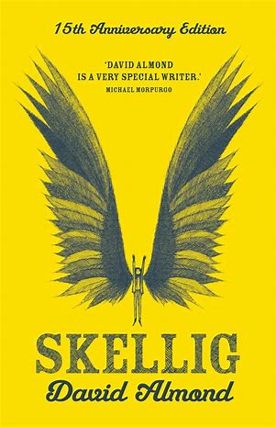

This Book Is A Bit Like:

The Sound of a Wild Snail Eating

I would rate this book:

Non-fiction

Fiction