**Year 11 Book Review**

I am reviewing....

Wuthering Heights

Written by...

Emily Bronte

Review by Mishel

This book is:

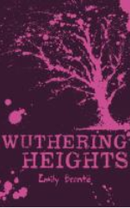

**I like the book because…**

It grants a clearer image between literature and life, the misfortune that humans experience and the desire of control. We see this through the characters as well as themes, such as heartbreak, grief and the unknown future.

As every new character was built, Bronte made sure to perfectly describe both their physical wellbeing as well as their mental wellbeing, which helps the readers paint up an extraordinary picture of their character. Most of the characters attribute to at least one problematic part, including the side characters. I highly recommend…

**A little bit about the book:**

This book is a classic, which is full of mystery and the downfall as well as the beauty of human nature and natural emotions such as jealousy, rage, ease and passion. Emily Bronte herself was passionate and had a bright spark for writing, which is evident in this book. All the characters have flaws, which leads them downhill but how they regain strength is what we learn and is what is most significant.

This book is a bit like…

‘Jane Eyre’

‘Pride and Prejudice’

‘The Little Friend’

I would rate this book:

Non-fiction

Fiction