**Year 10 Book Review**

This book is a bit like…

**A Study in Scarlet by Sherlock Holmes**

A little bit about the book:

There is a legendary curse that has apparently claimed one more victim. Sherlock Holmes, along with his companion, Dr Watson, is called to examine and investigate what is happening and what this hound is. But all is not what it seems…

I liked the book because…

Sherlock Holmes is brilliant at writing mysteries that make you think about how the crime is going to be solved. As it is set in an eerie setting and encapsulates the theme of the supernatural, it is definitely a captivating story that needs reading until the end.

I am reviewing....

The Hound of the Baskervilles

Written by...

Sherlock Holmes

Review by Khadija

This book is:

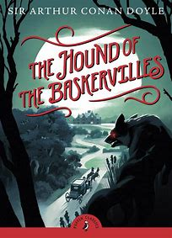

I would rate this book:

Non-fiction

Fiction