**Year 10 Book Review**

This book is a bit like…

Bright and Pale

A little bit about the book:

After her mother dies in an accident, sixteen-year-old Bree Matthews wants nothing to do with her family memories or childhood home. A residential program for bright high schoolers at UNC–Chapel Hill seems like the perfect escape—until Bree witnesses a magical attack her very first night on campus.

I liked the book because…

A long read, but definitely worth it! It managed to perfectly combine all the fantasy elements of a story, from secret societies and magical systems and demons, whilst still allowing the characters to navigate through more relevant issues: racism, classism, discrimination. The characters were interesting to read about and the plot twist at the end will make you kick yourself for not seeing it coming.

I am reviewing....

Legend Born

Written by...

Tracey Deonn

Review by Jamila

This book is:

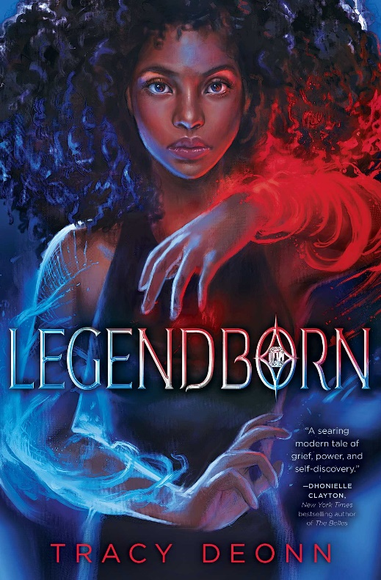

I would rate this book:

Non-fiction

Fiction