**Year 10 Book Review**

I would rate this book:

I am reviewing....

And then there were none

Written by...

Agatha Christie

Review by…

Shakira

This book is:

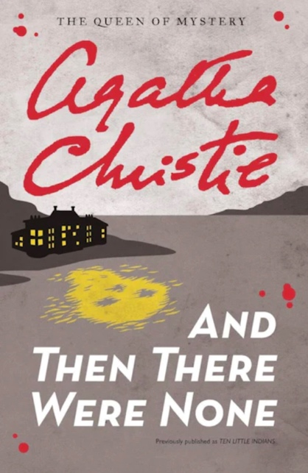

Non-fiction

Fiction

A little bit about the book:

Seven guests, a newly hired secretary and two staff are gathered at a manor house on an isolated island by an unknown absentee host and are killed off one-by-one following the order of a poem.

This book is a bit like…

This book is like:

The Guest List

I liked this book because…

The book was thought provoking and engages the reader through the plethora of mysteries placed throughout the story. Overall, the book had a satisfying ending that wouldn’t be expected, keeping the reader guessing until the very end.